Practical lesson 1 : Medical microbiology and immunology, its aims and objectives, historical development. Systematics and classification of microorganisms. Morphology and classification of bacteria. Microbiological laboratory, working regime of microbiological laboratory. Methods of microbiological investigation. Microscopic method. Microscopes. Rules of the immersion microscopy. Preparation of smears from pathological material and pure culture of microbes. Aniline dyes. Simple staining method

Microbiology (Gk. mikros small, bios life, logos science) is the science of minute organisms, invisible to the naked eye, named microbes. It is the study of the laws of the life and development of micro-organisms, and also of the changes which they bring about in animal and plant organisms and in non-living matter.
Modern medical microbiology has become an extensive science. It is subdivided into bacteriology — the science of bacteria, the causative agents of a number of infectious diseases; virology — the science of viruses, non-cellular living systems capable of causing infectious diseases in man; immunology — the science which is concerned with the mechanisms of body protection against pathogenic micro-organisms and foreign cells and substances; mycology — the study of fungi pathogenie for man, and protozoology which deals with pathogenic, unicellular animal organisms. In addition, medical microbiology includes the study of the mechanisms of infection and the methods of specific therapy and prophylaxis of infectious diseases.
According to application fields special microbiology is divided to branches : medical microbiology , sаnitary microbiology , clinical microbiology , industrial microbiology , biotechnology , veterinary microbiology, agromicrobiology , cosmic microbiology
Medical microbiology : Learns features of disease causing microorganisms and pathological processes developing in microorganism during diseases. Main objectives of medical microbiology aredevelopment of laboratory diagnostics, specific prevention and treatment methods of diseases caused by microorganisms.
Sаnitary microbiology : Learns microorganism living in environment (air, water, soil etc.) and processes caused by them. The main aim of sanitary microbiology is to detect causative agents of infectious diseases from environment and conduct measures to prevent contamination of environment by microorganisms, thus preventing development of infectious diseases.
Clinical microbiology : A branch of medical microbiology learning diseases of human organ and systems caused by microbes and priciples and of microbiological diagnostics.
Industrial microbiology : Studies microorganisms used in production of food, organic molecules such as antibiotics, enzymes, vitamins, alcohol etc. Industrial microbiology is in close relationship with biotechnology learning producers of biologically active substances.
Biotechnology : Learns living organisms especially microorganisms, animal and plant cells used in industry. Its aim is to obtain metabolic products of living cells. Sometimes it is possible through bioeffects which are usually do not exist in nature.
Veterinary microbiology : Learns microorganisms causing diseases in animals and develops diagnostic, specific prevention and treatment methods used in diseases caused by them. Veterinary microbiology is related to medical microbiology- many microorganisms causing animal diseases are pathological for human as well.
Agromicrobiology : Studies microflora of soil, role of microorganism in plant nutrition and soil fertility, Studies phytopathogen microorganisms causing plant diseases and develops methods used in struggle with them.
Space microbiology : Studies effect of Space factors on microorganisms and human microflora, develops methods to prevent spread of microorganisms from Earth surface to space.
Immunology : Immunology is a science evolved together with microbiology and developed based on microbiology. Learns structure and function of immune systemsupporting inner homeostasis of organism. Immune competent cells of immune system produce protective reactions called immune reactions thus supporting inner stability of organism against genetically foreign substances called antigens by removing them from organism.
Aims: The study of pathogens for humans microorganisms and also diseases which are caused by them, pathogenesis of those illnesses, their laboratory diagnosis, treatment and prevention.
Objectives: Further study of roles of particular species of pathogen microbes in the etiology and in the pathogenesis of different human diseases, study of mechanisms of immunity formulation, development of diagnostics methods and method development of specific prevention and treatment.
The role of microbiology in the activity of the pharmacist: Understanding the principles of microbiology and human cell mechanisms allows pharmacists to discover antimicrobial drugs that would prevent an escalating number of communicable diseases. Pharmacists and microbiologists work synergistically to ensure that drug therapies target the opportunistic microbes without harming its human host
Microbiology began to develop as a science from the second half of the 19th century. The history of the development of microbiology is divided into several stages:
Theoretical stage: Hippocrates played an important role in formation of knowledge about infectious diseases in antic age medicine (IV-III b.c). He thought that epidemics are caused by rotting organic matter called miasma also called night air. Hippocrates theory existed until renaissance - ХIV century when a new theory of infectious diseases had emerged. In 1374 in Venice people suspected in plague were isolated for 40 days (quаrаntinа). In ХV-ХVI G.Fracastoro (1476-1553) suggested that diseases are caused by «living pathogenic agents» - cоntаgium vivum. He thought that these agents are nonvisible and live in environment, spread by air and environmental objects.
Mоrphological stage: The first prove of microorganisms existence was given by datch scientist Antonie van Leeuwenhoek(1632-1723). Antonie van Leeuwenhoek produced microscope lenses. His handcrafted microscope could magnify object 160-200 times. He discovered living organisms in dental plaque, faeces and other objects and called them «wild animals» - «аnimаlculа vivа». He sent his observation to London Royal Society.

Physiological stage: From ХIХ century middle scientists begun intensively learn bacterial physiology. This stage continuing to develop up to our days is called physiological stage. Researches of Louis Pasteur (1822-1895) played an important role in development of physiological stage. He studied the crystals of wine acid in the microscope, proved microbiological nature of alcoholic, lactic and butyric fermentation, demonstrated a new type of respiration – anaerobic – in some of microbes. Then he presented and proved his famous theory that there is no self-origin of life (microbes). He proved that spontaneous generation of living substases does not exist. Also he discovered the nature of rabies and developed the method of producing of antirabies vaccines and began to use this vaccine to treatment (prophylaxis). In 1798 the English physician E. Jenner published his results of vaccinations against smallpox. He proved that vaccination of human with cowpox protects them from infections with smallpox. Those discoveries played important role for further development theoretical and practical problems of prophylaxis and struggle against infectious deceases.
Robert Koch made a great progress of medical microbiology. He discovered a solid nutrient media (gelatin, coagulated serum, meat peptone agar (MPA) and applied them to isolating of pure cultures of microbes. He also introduced aniline dyes and immersion system in practice of microscopy. Koch proved the bacterial nature(etiology) of anthrax. He discovered choleric agent, tuberculosis agent and obtained tuberculin from tuberculoid bacterium. In 1892 Russian scientist D.I.Ivаnоvsкi learned tobacco mosaic disease discovered small microorganisms passing through bacterial filters and causing specific pathological processes – viruses. In the middle of ХХ century– virology formed as a distinct independent science learning viruses.
İmmunological stage: Great role of understanding of inflammation nature was made by I.E. Mechnikov – all basic ideas of immunology: immune status, immune resistance, specific and non-specific factors of defense.The classic works of Mechnikov on the biological theory of immunity opened a new stage in the development of medicine. He discovered and studied the process of intracellular digestion as a mechanism of defense against pathogenic microbes which have penetrated into the body. He discovered that some cells of mesoderma, leykocytes possess a defense mechanism against pathogenic microbes. Those cells were named phagocytes. That is why we now Mechnikov as a founder of cellular theory of immunity, in 1908 he was awarded Nobel prize.
Molecular-genetic stage: Discovery of DNA mоlеcule structure by J.Watsоn and F.Crick in 1953 is the beginning of new stage in development of microbiology and immunology. In addition, study of genomic and antigenic structure of microorganisms, molecular structure of immune globulins, immune response mechanism, immune systеm mеdiаtоrs, discovery of cytokines and application of new diagnostic methods - gеnеtic methods were stuied.
Classification of microorganisms.
The modern classification
There are 2 upper kingdom of living mater: procariotes and eucariotes.
Procariotes contain: Cianibacterium, Archebacterium, Eubacterium (true bacteria).
Eucariotes contain: animals, plants, fungi (micota).
In this group for microbiology are important:
From animals - class Protozoa
From plants – unicellular water-plants – Algae
From fungi – all microscopical representatives.
Main classification of bacteria is Bergey’s Manual, which include two divisions:
- Cyanobacteria (cyanophyta)
- True bacteria which include 19 parts.
Main of them represents:
- Bacteria (rod-like, cocci), (aerobic and anaerobic), (endospore forming or no);
- Spirochetes and spiriles;
- Vibrions;
- Actinomycetes (important as producents of antibiotics);
- Obligate intracellular parasites (Ricketsia and Chlamidia).
Viruses are grouped in an independent kingdom:
- Are genetic parasites
- No cell structures and protein synthesis systems
- On animals, insects, plants, bacteria (phages) and human
- Contain DNA or RNA
- Are not visible with the light microscope.
Each microorganism in systematics has its own taxonomy (greek, taxis – place, row). Taxonomy learns classification, identification and nomenclature of microorganisms.
Classification categories: Classification categories of microorganisms is the same as in other organisms : dоmеn - kingdom –class– order - family – genus – species. Some categories are changed depending on microorganism representatives. For exp., in animals «family» category is used, while in plants and microbes «order» is used.
The main classificarion category – species consists of microorganisms with the same origin and similar morpho-biological features
Species have:
• Strains with different morphological features - mоrphоvаrs,
• Strains with different biological features– biоvаrs,
• Strains with different antigenic features– sеrоvаrs,
• Strains with different susceptibility to phages– phagоvаrs etc.
• One species of microorganisms consists of manyn strains.
• Strain –microorganism related to one species obtained from different sources or from the same source in different time.

Modern classification divides microorganisms to 2 groups: cellular and acellular.
• Acellular(akaryotes) microorganisms belong to a special кingdоm.
• Cellular microorganisms belong to 3 domains: bacteria, archebacteria, and eukarya.
• Bacteria domain consists of true bacteria (eubacteria, greek, еu - true), archebacteria domain consists archebacteria (both domains - prokaryotes),
• Domain Euкаryа consists of eukaryotic microorganisms.

Acellular microorganisms(акаryоtes)
• Unlike prokaryotes and eukaryotes they do not have cellular elements – cell wall, cytoplasm, and other subcellular structures.
• Includes of viruses, virоids and priоns

Cellular microorganisms
• Divided to prokaryotes and eukaryotes.
• Prokaryotes modern classification is based on Bergey classification. This classification first introduced by American bacteriologist Bergey in 1923, is annually updated by International Committee on Classification of Bacteria
• According to last update – 9 th edition all prokaryotes depending on cell wall structure divided to 4 categories.
• Each category consists of many groups.
Bergey classification of prokaryotes:
• Gram negative eubacteria with cell wall
• Gram positive eubacteria with cell wall
• Eubacteria lacking cell wall
• Archebacteria
Classification of Еuкаryotic microorganisms
• Еuкаryotic microorganism are included in «еuкаriyа» dоmain.
• Unlike Prokaryotes they have formed nucleus which is separated from cytoplasm by special membrane.
• Eukaryotic microorganisms include Fungi and protozoans
Principles of the bacterial classification.
All bacteria have binary nomenclature:
Genus and Species:
– pool of microorganisms with common origin, similar genotype (>60% of DNA homology) and maximum adjacent phenotypic signs and properties.
Additional terms:
Clone – a population of microorganisms descended from a single individual by asexual reproduction.
Strain – clones that are presumed or known to be genetically different. (it is specimen of microbic culture the same species, which was isolated from different places or from one place in different times.
Cocci: monococci, diplococcic (gonococci, meningococci, pneumococci), streptococci, staphiococci, tetracocci, sarcines (8-16 cells).
Rod-like: mono, strepto, diplo; with or without spores.
Spirals forms: vibrio, spirillae.
The methods of microbiology investigation

Modern diagnostic methods in microbiology
1. Microscopic methods
Light microscopes: fluorescenes, dark-field, etc.
Electron microscopes.
2. Bacteriological or physiological methods
Isolation of pure culture and its identification
Grow on special nutrient media. Investigation of fermentative activity of microbes.
3. Biological methods
Infection of laboratory animal
Investigation of diagnostical triade:
- Isolation of causative agent from sick human
- Microscopy of obtained material
- Isolation of pure culture and its investigation
- Modeling of the decease on laboratory animal
4. Immunological methods
Serological reaction. Identification of antigenic composition of bacteria.
Determine specific antibodies or antigens in patients’ blood.
Investigation of patient serum with serological reactions: agglutination, precipitation, ELISA, immunofluorescence etc.
Skin-Allergic tests. Sensitivity of macro organism to various infectious agents or their metabolites.
5. Genetics methods
Investigation DNA (RNA) sequence. Polymerase chain reaction (PCR).

Microscopic method. Microscopes

The microscope is an instrument used to view the micro world. The microscope has multiple lens to pick up the image from the specimen and magnify it.
Microscopes can be separated into optical theory microscopes (Light microscope - bright-field microscope, dark-field microscope, phase contrast microscope. Fluorescence and confocal microscopes are specialized instruments, used for research, clinical, and industrial applications.), electron microscopes and scanning probe microscopes (SPM). Optical microscopes function through the optical theory of lenses in order to magnify the image generated by the passage of a wave through the sample or reflected by the sample. The waves used are electromagnetic (in optical microscopes or electron beams (in electron microscopes). Types are the compound light, stereo and the electronic microscope. Light microscope produces a dark image against brighter background. Commonly used to view stained cells. Simple microscopes have single magnifying lens (like a magnifying glass). Compound microscopes have two sets of lenses for magnification.
An optical compound light microscope uses objectives on a turret that can be turned to select various powers of magnification. It compounds the magnification by use of the eyepieces which typically have a 10x or 16x magnification power. The resultant magnification is the multiplication of the objective power by the eyepiece power.
Essentially, a compound microscope consists of structural and optical components. However, within these two basic systems, there are some essential components that every microscopist should know and understand. The three basic structural components of a compound microscope are the head, base and arm (Fig.11).
- Head/Body houses the optical parts in the upper part of the microscope
- Base of the microscope supports the microscope and houses the illuminator
- Arm connects to the base and supports the microscope head. It is also used to carry the microscope.
When carrying microscope always take care to lift it by both the arm and base, simultaneously.
The are two optical system in a microscope. Eyepiece, lenses and objective lenses. Eyepiece or ocular is what you look through at the top of the microscope. Typically, standard eyepieces have a magnifying power of 10x. Optional eyepieces of varying powers are available, typically from 5x-30x. Eyepiece tube holds the eyepieces in place above the objective lens. Objective lenses are the primary optical lenses on a microscope. They range from 4x-100x and typically, include three, four or five on lens on most microscopes. Objectives can be forward or rear-facing. Standard objectives include 4x, 10x, 40x and 100x although different power objectives are available. Coarse and fine focus knobs are used to focus the microscope. Stage is where the specimen to be viewed is placed. Stage clips are used when there is no mechanical stage. The viewer is required to move the slide manually to view different sections of the specimen. Aperture is the hole in the stage through which the base (transmitted) light reaches the stage. Illuminator is the light source for a microscope, typically located in the base of the microscope. Most light microscopes use low voltage, halogen bulbs with continuous variable lighting control located within the base. Condenser is used to collect and focus the light from the illuminator on to the specimen. It is located under the stage often in conjunction with an iris diaphragm. Iris Diaphragm controls the amount of light reaching the specimen. It is located above the condenser and below the stage. Most high quality microscopes include condenser with an iris diaphragm. Combined, they control both the focus and quantity of light applied to the specimen.
The optical microscope remains the fundamental tool for phase identification. The optical microscope magnifies an image by sending a beam of light through the object as seen in the schematic diagram of Figure 12. The condenser lens focuses the light on the sample and the objective lenses (10X, 40X, . . . , 2000X) magnifies the beam, which contains the image, to the projector lens so the image can be viewed by the observer.
Bright Field Microscopy. With a conventional bright field microscope, light from an incandescent source is aimed toward a lens beneath the stage called the condenser, through the specimen, through an objective lens, and to the eye through a second magnifying lens, the ocular or eyepiece. A disadvantage of having to rely solely on an aperture diaphragm for contrast is that beyond an optimum point the more contrast you produce the more you distort the image. With a small, unstained, unpigmented specimen, you are usually past optimum contrast when you begin to see the image.

Figure 13. Schematic diagram of the bright and dark field microscopy.

Dark Field Microscopy. Dark field optics are a low cost alternative to phase contrast optics. To view a specimen in dark field, an opaque disc is placed underneath the condenser lens, so that only light that is scattered by objects on the slide can reach the eye (Fig.13). Instead of coming up through the specimen, the light is reflected by particles on the slide. Everything is visible regardless of color, usually bright white against a dark background. Pigmented objects are often seen in "false colors," that is, the reflected light is of a color different than the color of the object. Better resolution can be obtained using dark field as opposed to bright field viewing.
Phase Contrast Microscopy. In 1933 Dutch physicist Frederick Zernike demonstrated a type of microscope that greatly improved our ability to study the internal structure of living cells. This instrument is known as the phase-contrast microscope.
Highly refractive structures bend light to a much greater angle than do structures of low refractive index. The same properties that cause the light to bend also delay the passage of light by a quarter of a wavelength or so.
In a light microscope in bright field mode, light from highly refractive structures bends farther away from the center of the lens than light from less refractive structures and arrives about a quarter of a wavelength out of phase. Phase contrast is preferable to bright field microscopy when high magnifications (400x, 1000x) are needed and the specimen is colorless or the details so fine that color does not show up well. Cilia and flagella, for example, are nearly invisible in bright field but show up in sharp contrast in phase contrast.

Figure 14. Phase Contrast Microscope
Fluorescence microscope. This is a compound microscope in which all the optical elements are made of quartz. A Mercury arc or Xenon burner is used as the light source and the short wave ultra-violet light allows resolution of about twice that possible with visible light. A fluorescence microscope is a microscope which is used to examine specimens with luminescent properties, or specimens which have been prepared with substances which create luminescent properties. In this type of microscopy, the specimen itself is the light source. A great deal of information can be collected with the use of a fluorescence microscope, and these microscopes can also be used to create stunning images in which detailed structures are clearly visible. This microscopes take advantage of the properties of certain chemical compounds. When excited by light of the proper wavelength, classically ultraviolet light, these chemicals will light up.
Electron microscope. The electron microscope is a type of microscope that uses a beam of electrons to create an image of the specimen. Researchers use it to examine biological materials (such as microorganisms and cells), a variety of large molecules, medical biopsy samples. It is capable of much higher magnifications and has a greater resolving power than a light microscope, allowing it to see much smaller objects in finer detail. All electron microscopes use electromagnetic and/or electrostatic lenses to control the path of electrons. Glass lenses, used in light microscopes, have no effect on the electron beam. The basic design of an electromagnetic lens is a solenoid (a coil of wire around the outside of a tube) through which one can pass a current, thereby inducing an electromagnetic field. The electron beam passes through the centre of such solenoids on its way down the column of the electron microscope towards the sample. Electrons are very sensitive to magnetic fields and can therefore be controlled by changing the current through the lenses.

Microscopy with Oil Immersion
Resolving Power
It might seem that infinite magnification could be achieved simply by increasing the power of the ocular and objective but lenses are limited by a phenomenon known as resolving power, or resolution. As two small objects are moved closer to each other, a point is reached where the lens is unable to distinguish the objects as separate entities, and only a single object is observed. The smallest distance at which two points can be seen separately is called the resolving power of the lens. The resolving power of the human eye is 0.1 mm.
The resolving power is determined by the wavelength of light and the numerical aperture. The relationship of these two factors can be expressed as follows:
Wavelength / Resolving power = numerical aperture
If you keep in mind that a high resolving power represents a low numerical value, it is easy to understand from the above formula that the shorter the wavelength of light, the greater will be the resolving power. Since the shortest wavelength of visible light is at the violet end of the spectrum (380-460 nm), it follows, then that a bluish-violet filter should be in place between the light bulb and slide to absorb the longer wavelength, allowing only blue and violet light to pass through.
As beneficial as the shortest wavelengths are to improving resolution, much more can be gained by increasing the numerical aperture of the objective and condenser. The condenser is a light-gathering lens system under the stage which concentrates the available light on the specimen. It can be moved up and down by manipulating the substage adjustment knob.
The numerical aperture (N.A.) is a mathematical expression of the solid cone of light delivered to the specimen by the condenser and gathered by the objective. The higher the N.A. of an objective (and condenser), the greater is the amount of light passing up through the microscope, and the greater is the resolution.
An unfortunate consequence of light passing through air from the glass slide to the objective lens is that considerable light is lost due to the refractive differences of glass and air. This light loss, in effect, reduces the numerical aperture and consequently the resolution of the objective lens. If the oil, such as cedarwood or mineral, which has a refractive index similar to glass, is interposed, this light loss does not occur. When immersion oil is used with the 100x objective, a numerical aperture of 2,0 may be achieved, the resolving power of a good compound microscope is around 0,2 mcm.

Illumination
Although the light source for a microscope might be the sun or an incandescent bulb, the latter a lamp is preferred in microbiological work because its color, temperature and intensity can be more easily controlled and stabilized. If the microscope has a mirror to be used with a lamp, the flat surface always is used. Microscopes with condensers require the parallel rays of the light that are reflected from the mirror which concentrates more light into the objectives.
Unless instructed otherwise, always keep the condenser at its highest position. When using the 100x objective and immersion oil the diaphragm should be left completely open on most microscopes.
To get the maximum amount of light entering the microscope, it is important that the mirror, condenser and lenses be kept clean.
Focusing
To focus a microscope, it is necessary to alter the distance between the slide and the objective lens. This is accomplished by knobs on the side of the microscope. On some instruments these knobs cause the objective lens to move up and down with relation to the stage. On other microscopes the objective lens is stationary and the stage is moved up and down. In either case, when considerable travel is desired, the larger knob is used. For critical focusing the smaller knob is used.
When focusing, consideration must be given to the working distance of the lens. This is distance between the lens and the slide when the specimen is seen in sharp focus. The greater the power of an objective, the less is its working distance. Note that the oil immersion lens has only 0,18 mm clearance. If a slide is used with a thin cover glass, the actual working distance will be even less; therefore, in all cases, care must be exercised that the oil immersion lens is not damaged when this close to the slide. Although most microscopes have built-in mechanisms to prevent damage to this lens, the safest procedure is to make it a rule never to try to decrease the distance between the objective and specimen while looking down through the microscope. A much better procedure is to watch the objective from the side of the microscope as the distance is closed and then to look through the microscope as the distance is increased while bringing the image into focus.
High-Dry Examination
Once the microscopic field has been surveyed to locate a desired object, one can change the magnification by utilizing the high-dry objective. This lens will increase the magnification four or five times more than low power, making cellular detail much clearer. All that is necessary is to rotate the nosepiece so that the high-dry objective is locked in place over the slide. Since most good laboratory microscopes are of parfocal design, it can be assumed that the specimen under high-dry will be in focus (or nearly so) if it was in focus under low power. Only inexpensive microscopes or instruments that are out of adjustment will lack parfocalization. When changing from low power to high-dry, keep these points in mind:
- For optimum clarity the slide should have a cover glass on it.
- Be sure the microscope is in focus under low power before changing to high-dry. Often students will increase the distance between the objective and slide just before changing to high-dry for fear that they might strike the slide with the objective. This is a mistake. It is important to remember that once the objective is in focus under low power, the high-dry can be safely rotated into place.
- Open the diaphragm sufficiently to increase the illumination and bring it into sharp focus with the fine adjustment knob.
- Keep the condenser at its highest point, unless instructed otherwise.

Oil Immersion Techniques
For all bacteriological examinations, as well as for certain types of blood cell studies, it will be necessary to use the oil immersion (100x) objective. The greatest difficulty students have with this lens is that its working distance (0,14 mm) is so small that cover glasses are often broken when it is used the first time. Two methods for using the oil immersion lens follow:
Method 1. The easiest (and safest) procedure is to progress from low power to oil immersion. This may be accomplished by passing the high-dry objective, if desired. Microscopes of parfocal design make it as easy to progress from low power to oil immersion as from high-dry to oil immersion. In either case, once the microscope has been in focus at one magnification, the oil immersion lens can be safely rotated into position. Before moving it into position, however, a drop of immersion oil should be placed on the slide first. Slight adjustment of the fine adjustment knob is usually necessary to sharpen the focus. It also will be necessary to open up the diaphragm to its maximum aperture.
Method 2. The oil immersion objective of a microscope should be lowered into the oil on the slide until the objective just barely touches the slide. It is necessary to watch the objective from the side as it approaches the slide. Bringing the image into focus is achieved by turning the fine adjustment knob very slowly to increase the distance between the slide and lens.
Smear preparation

The first step in preparing a bacteriological smear differs according to the type of medium from which the organisms are removed. To prepare bacteria for staining a sample of bacteria in liquid (broth, milk, saliva, urine, etc.) is spread as a thin layer or smear on a clean glass slide. Make a thin film of the material on a clean glass slide, using a sterile loop or swab for viscous specimens.
Place the loop in flame (Bunsen
burner) starting at the loop and move it through the flame so that the wire becomes red-hot along 4 to 6 cm of its length (Fig.1). Allow the wire to cool for about 10 seconds. Pick up the sample with the cooled loop and distribute it. Repeat the flaming - cooling procedure before laying the loop down on the desk.
Procedure from Liquid Media
(from broth, saliva, milk, etc.)
Materials: microscope slides, inoculating loop, Bunsen burner, marking pencil)
1. Wash a slide with soap and removing all dirt and grease. Handle the clean side by the edges (Fig.18)
2. Write the initials of the organism or organisms on the left-hand side of the slide with a marking pencil.
3. To provide a target on which to place the organisms, make a one-two cm
circle on the bottom side of the slide, centrally located, with a marking pencil.
4. Shake the culture vigorously and transfer two loopfuls of organisms to the center of the slide over the target circle (Fig.19). Be sure to sterilize the loop after it has touched the slide.
5. Spread the organisms over an area about one-two cm in diameter.
6. Allow the slide to dry by normal evaporation of the water.
7. After the smear has become
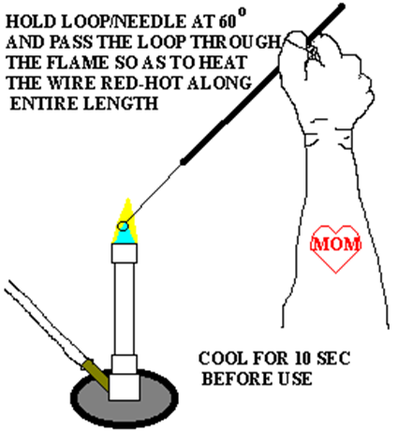Figure 18. Flaming of loop completely dry, pass the slide over a
Bunsen burner flame to heat-kill and
fix the organisms to the slide.
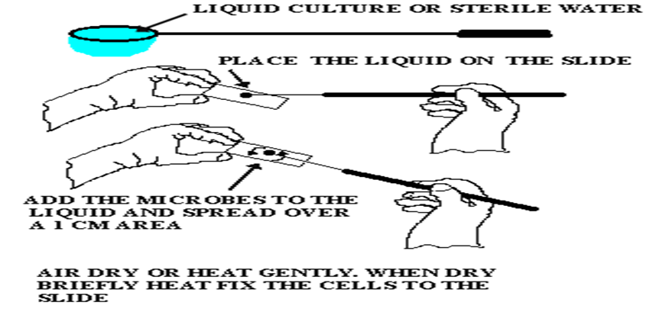
Figure 19. Preparation of a microbial smear
When cerebrospinal fluid contains only a few organisms, they are more likely to be found if a concentrated "thick smear" is examined. To prepare a "thick smear" the specimen is spun at high speed and a large drop of sediment (or multiple drops, drying in between each drop) is placed in the center of the slide and allowed to air dry. The cytocentrifuge may prove to be useful in concentrating bacteria as well as in preserving cell morphology.
Two types of smears are prepared from the peripheral blood – one thin smear and the other thick smear. Thick film examination is about 20 times more sensitive than thin film examination for parasite detection. Thin film examination is done for finding out the species of Plasmodium. Prepare the thin and thick blood smears in the following way:
For thin blood smear take a clean, dust free, grease free slide and take 3 drops of the blood 1 cm from the edge of the glass slide. Take another drop of blood one cm from the first drop of blood (Fig.20). Take another clean slide with smooth edges and use it as a spreader. Make thin smear by bringing in contact the spreader with the drop of blood at an angle of 30-45° from the horizontal and pushing the spreader steadily down the surface of the slide drawing the blood behind till the smear is formed.
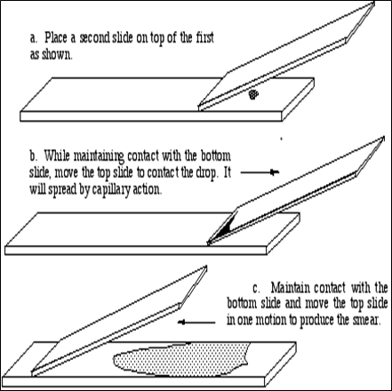 Figure 20. Thin blood smear
Make thick smear by joining the 3 drops of blood and spreading it in an area of 10 mm diameter (Fig.21). For thick film preparation, a small drop of blood is placed on a glass slide and spread to approximately 4 time its original surfaces. After extensive drying, best done at 50°C to 60°C for 7 to 10 minutes, the slides can be stained. The cell will wash off slide if insufficiently dried.

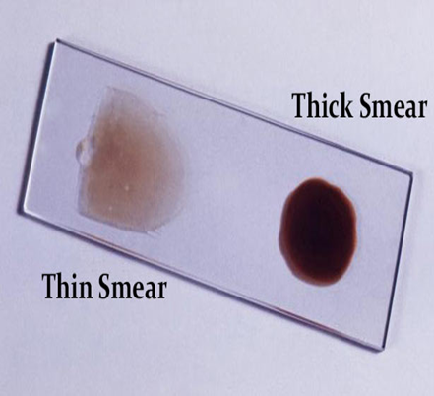Figure 21. Thick blood smear

Procedure from Solid Media (pure cultures)
Materials: microscope slides, inoculating loop, Bunsen burner, marking pencil
- Wash a slide with soap and removing all dirt and grease. Handle the clean side by the edges.
- Write the initials of the organism or organisms on the left-hand side of the slide with a marking pencil.
- Flame the loop (needle) and take sterile water
- Place a loopful of sterile water on the slide
- With an inoculating needle pick up a very small amount of organisms (culture from solid media) and mix them into the liquid on the slide. Spread them over an area of about one-two cm diameter. Be certain that the organisms have been well emulsified in the liquid
- Allow the slide to dry by normal evaporation of the water
- After the smear has become completely dry, pass the slide over the flame of a Bunsen burner to heat-kill and fix the organisms to the slide

Fixation methods
The fixation procedure is the same regardless of smear source, plate or broth. There are two methods of fixation:
- physical
- chemical
Physical methods include heating, micro-waving and cryo-preservation (freeze drying).
- Heat fixation is rarely used on tissue specimens, its application being confined to smears of microorganisms.
Procedure
1. In order to heat fix a bacterial smear, it is necessary to first let the bacterial sample air dry.
2. Pass the dried slide through the flame of a Bunsen burner 3 or 4 times, smear side facing up (Fig.23 A-B).
3. Once the slide is heat fixed, it can then be stained.
Chemical fixation is usually used fixative solution which by immersing the specimen in the fixative. For chemical fixation is used methanol, ethanol, formaldehyde, acetone. Chemical fixation is usually applicated on tissue specimens (e.g. thin blood smear). Methanol fixation causes fewer changes in cellular morphology and creates no aerosols.
Procedure
1. Be sure your slide is totally dry. Set it on the staining rack over the sink.
2. Carefully flood the slide with 95% methanol. Let it sit for two minutes.
3. Tilt the slide and pour off the methanol. Touch the edge of the slide to a paper towel to wick off the excess methanol (Fig.23 C-D).
4. Set the slide aside to air dry before staining.
Fixation process accomplishes some things:
- kills the bacteria, can't infected environment
- the organism stains better
- firmly attaches the smear to the microscope slide
- allows the sample to more readily take up the stain
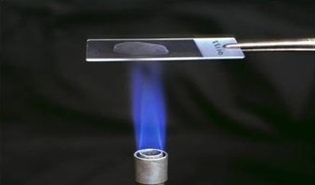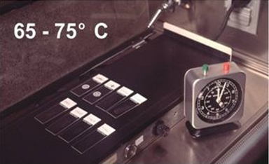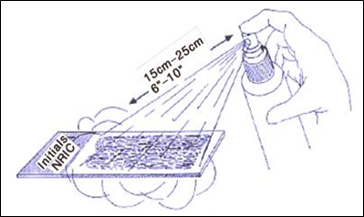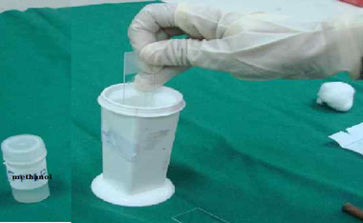
Figure 23. Smear fixation methods
Simple Staining
Bacteria are almost colorless (remember, all cells composed primarily of water) and therefore show little contrast with the broth in which they are suspended. To visualize bacteria, either dyes or stains, or an alternative source of illumination (phase contrast or differential interferrence contarst) are used. Since staining of bacterial cells is relatively fast, inexpensive, and simple, it is the most commonly used technique to visualize bacterial cells. Staining not only makes bacteria more easily seen, but it allows their morphology (e.g. size and shape) to be visualized more easily. In some cases, specific stains can be used to visualize certain structures (flagella, capsules, endospores, etc) of bacterial cells. There are several staining methods that are used routinely with bacteria. These methods may be classified as 1) simple (nonspecific) and 2) differential (specific). Simple stains will react with all microbes in an identical fashion. They are used solely for increasing contrast so that morphology, size and arrangement of organisms can be determined. Differential stains give varying results depending on the organism being treated. These results are often helpful in identifying the microbe.
The use of a single stain to color a bacterial organism is commonly referred to as simple staining. Some of the most commonly used dyes for simple staining are methylene blue, basic funchsin, and crystal violet. All of these dyes work well on bacteria because they have color bearing ions (chromophores) that are positively charged (cationic). The fact that bacteria are slightly negatively charged produces a pronounced attraction between these cationic chromophores and the organism. Such dyes are classified as basic dyes. The basic dye methylene blue (methylene⁺chloride⁻) will be used in this exercise. Those dyes that have ionicchromophores are called acidic dyes. Eosin (sodium⁺eosinate⁻) is such a dye.
The staining times for most simple stains are relatively short, usually from 30 seconds to 2 minutes, depending on the dye affinity. After a smear has been stained for the required time, it is washed off gently, blotted dry, and examined directly under oil immersion. Such a slide is useful in determining basic morphology.
Staining Procedure
1. Prepare a smear on clean grease free slide.
2. Air dry and heat fix the smear.

3. Stain the smear by flooding it with one of the staining solutions and

allowing it to remain covered with the stain for the time designated

below (Fig.24):

Methylene blue - 1 minute

Crystal violet - 30 seconds

Carbol fuchsin - 20 seconds
4. Wash the slide with water, air dry and observe under oil immersion
lens.

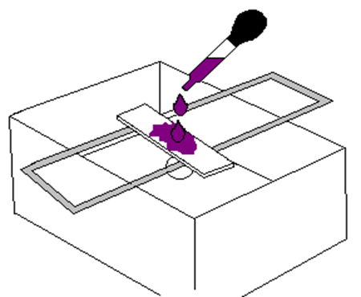 Figure 24. Simple staning

